Caleb Smith
CS 340
Professor Kellogg
June 17, 2026
Project Three README
Project Overview
This project was created for Grazioso Salvare, an international rescue animal training organization. The dashboard lets users explore animal shelter data stored in MongoDB and identify dogs that match search-and-rescue training criteria. It includes interactive filters, a dynamic data table, a geolocation map, and visualizations that help users quickly evaluate potential rescue dog candidates.
Dashboard Functionality
The dashboard includes the following features:
- Displays all animal records from the Austin Animal Center Outcomes database.
- Filters records by rescue category:
  - Water Rescue
  - Mountain or Wilderness Rescue
  - Disaster Rescue or Individual Tracking
  - Reset to show all records
- Shows filtered results in an interactive data table.
- Shows a geolocation map for the selected animal.
- Displays a pie chart of breed distribution for the filtered dataset.
- Includes the Grazioso Salvare logo and developer identification.

Initial Dashboard State
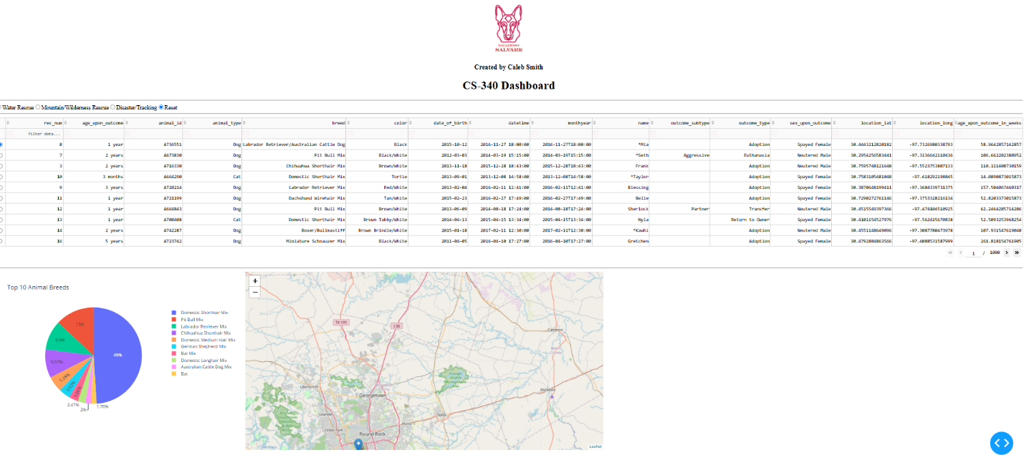When first loaded, the dashboard shows all database records along with filtering controls, the pie chart, and the geolocation map.
Water Rescue Filter
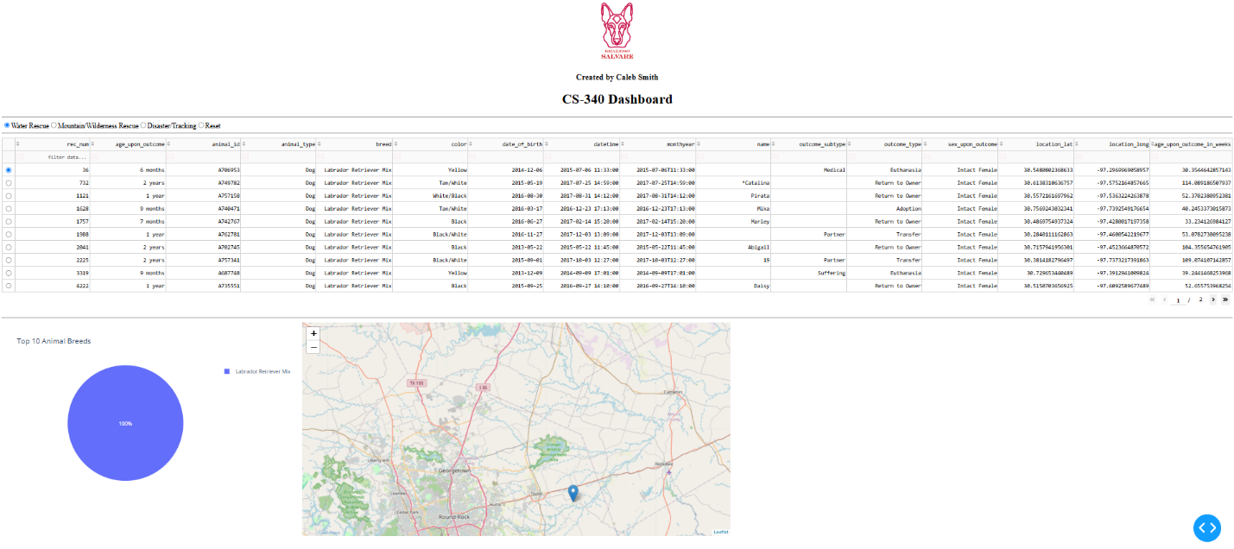This filter shows dogs that meet Grazioso Salvare's water rescue training requirements.

Mountain or Wilderness Rescue Filter
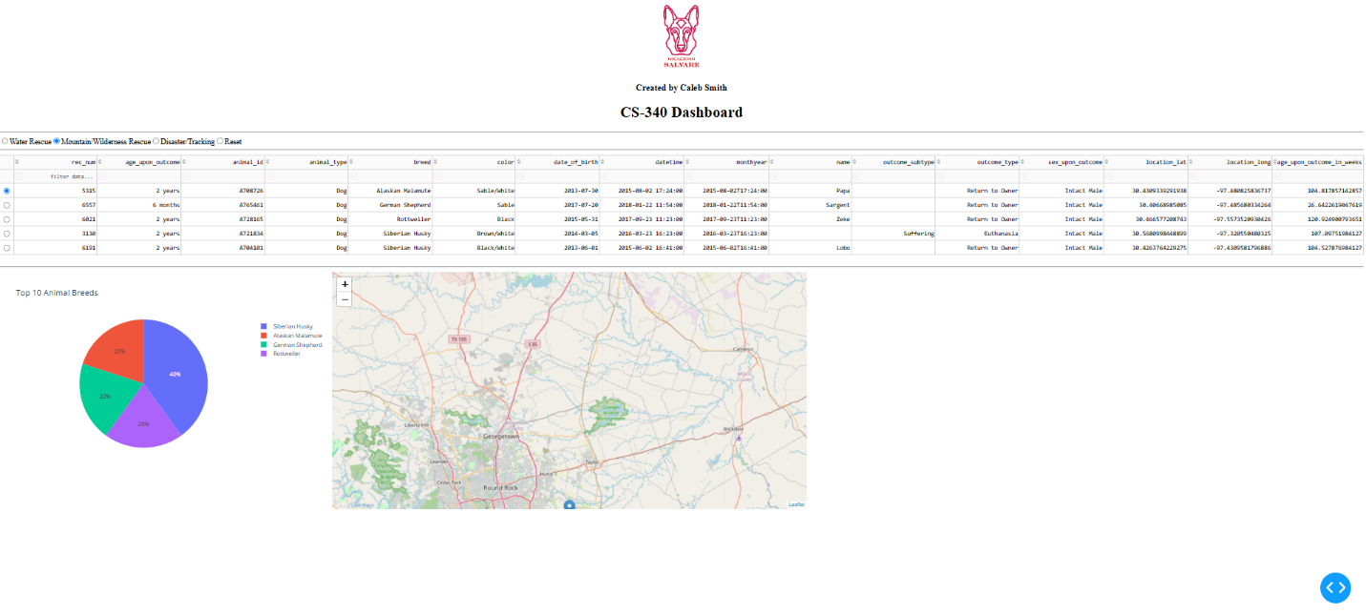This filter shows dogs that meet mountain or wilderness rescue training requirements.
Disaster Rescue or Individual Tracking Filter
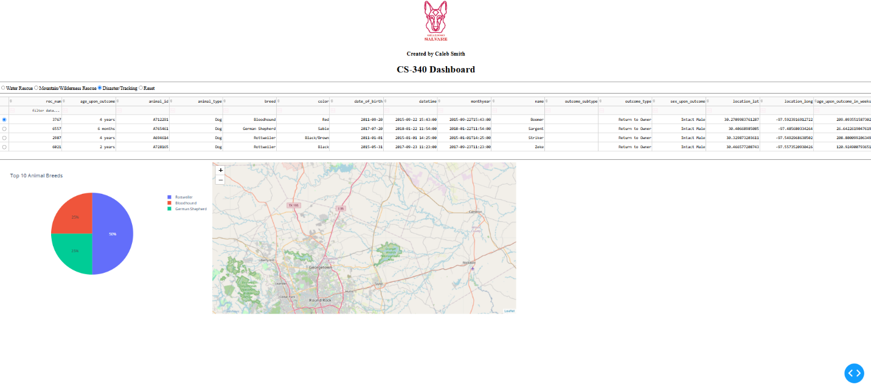This filter shows dogs suited for disaster rescue and individual tracking operations.

Reset Filter
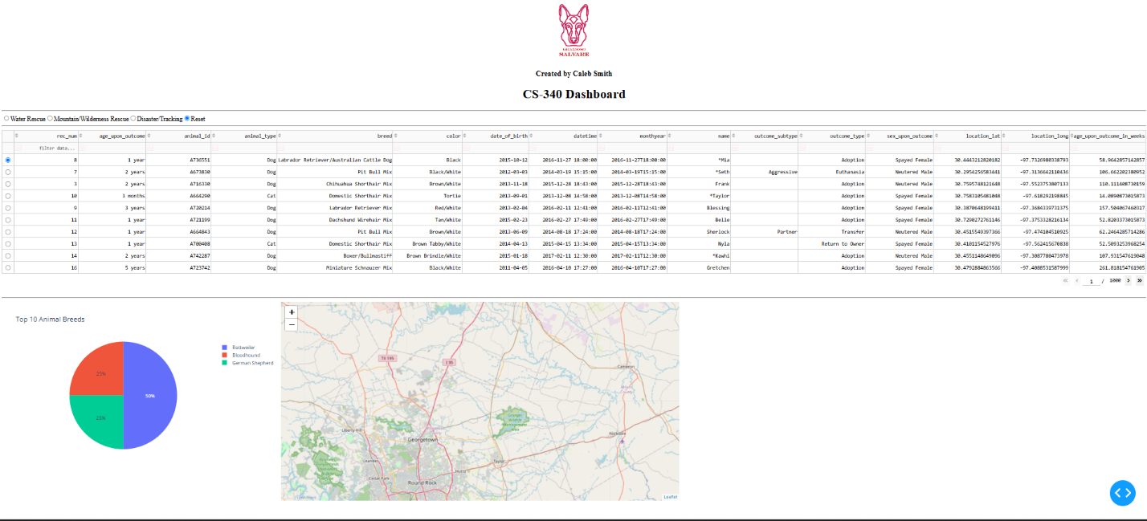This option clears active filters and restores the dashboard to its original view.

Tools and Technologies Used
Python
Python served as the primary language for building the dashboard and database interface.
MongoDB
MongoDB was used as the database because it stores flexible JSON-like documents and integrates easily with Python through PyMongo. It supports efficient queries and retrieval of animal records for the dashboard's filtering needs.
PyMongo
PyMongo connected Python to MongoDB. The custom CRUD module from Project One used PyMongo to create, read, update, and delete database records.
Dash
Dash was used to build the web application dashboard. Its interactive components, including radio buttons, tables, charts, and maps, update dynamically based on user input.
Dash DataTable
Dash DataTable displayed and filtered animal records in an easy-to-use table.
Plotly Express
Plotly Express generated the interactive pie chart showing breed distribution.
Dash Leaflet
Dash Leaflet created the geolocation map and displayed animal locations using latitude and longitude coordinates.
Pandas
Pandas organized MongoDB data into DataFrames for dashboard display.

Project Development Process
Development included the following steps:
- Created a MongoDB database with Austin Animal Center animal records.
- Built a CRUD Python module to interact with MongoDB.
- Created an unfiltered data table showing all records.
- Wrote MongoDB queries for each rescue category.
- Added radio buttons so users can select rescue categories.
- Linked dashboard controls to MongoDB queries with Dash callbacks.
- Created a dynamic pie chart that updates when filters change.
- Created a dynamic geolocation map that updates based on table selections.
- Added Grazioso Salvare branding and developer identification.
- Tested dashboard functionality and documented results with screenshots.

Challenges Encountered
MongoDB Authentication
A key challenge was connecting the dashboard to MongoDB. Authentication errors were fixed by verifying the MongoDB username and password and confirming that the CRUD module used the correct connection string.
Dashboard Callback Errors
Several callback errors occurred because of duplicate outputs and undefined query variables. These were resolved by simplifying the callback functions and defining rescue queries before the callback logic.
Data Formatting Issues
MongoDB returned ObjectId values that caused Dash DataTable display issues. Removing the _id field from the DataFrame before display prevented these errors.
Dashboard Layout and Branding
Additional layout adjustments were needed to display the Grazioso Salvare logo and developer identification correctly.

